Assignment Title

Student no.

1 INTRODUCTION
Concise description of task asked and your approach(es).

2 EXPERIMENTATION

Describe your basic algorithm so anyone who knows about basic EAs could hopefully repeat what you have done. Describe the representation, the parameters, the fitness calculation, etc.

Present your results as averaged behaviour over more than one run, eg (graph not of assignment):
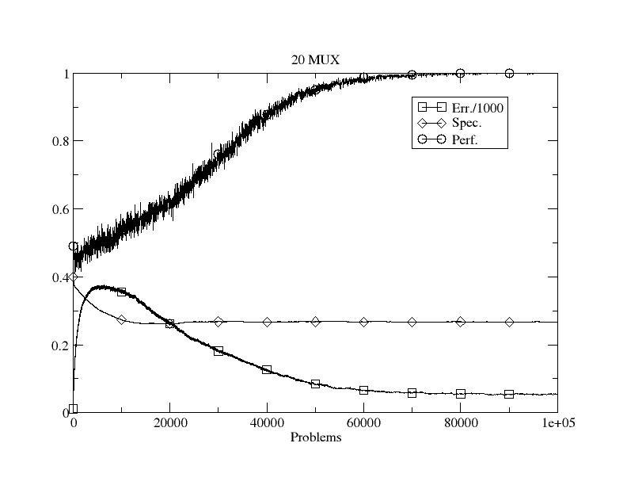
Figure Example: Initial performance.

Show the effects of varying parameters and give potential explanations as to why the behaviour/performance changes. Eg vary the mutation rate or population size. Show example solutions. Try different operators from the lectures or wider literature.

Results from the worksheets should not be included.

3 COMPARISON
Show comparative performance of other well-known approaches to the optimisation problems provided. You don’t need to implement other algorithms, use of open source, etc. is fine. For the very keen, other benchmark functions can be explored as well.

4 CONCLUSIONS
Concise summary of what you found and learned. Identification of ways you might do things differently next time, and why.

REFERENCES
Author, A. (1970) The best way to do AI ever. IEEE Transactions on Data Mining 1(1): 209-238.

Source code as an appendix

